**16-BIT ADDITION:**

**EXP NO:5**

**AIM:**To write an assembly language program to implement 16-bit addition using an 8085 processor.

**APPARATUS:** GNUSim8085

**ALGORITHM:**

1)Start the program by loading a register pair with the address of 1st number.  
2) Copy the data to another register pair.  
3) Load the second number to the first register pair.  
4) Add the two register pair contents.  
5) Store the result in memory locations.  
6) Terminate the program.   
**PROGRAM:**

LHLD 2500  
XCHG  
LHLD 2502  
DAD D  
SHLD 2504  
HLT

**INPUT:**

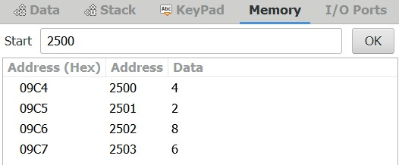

**OUTPUT:**

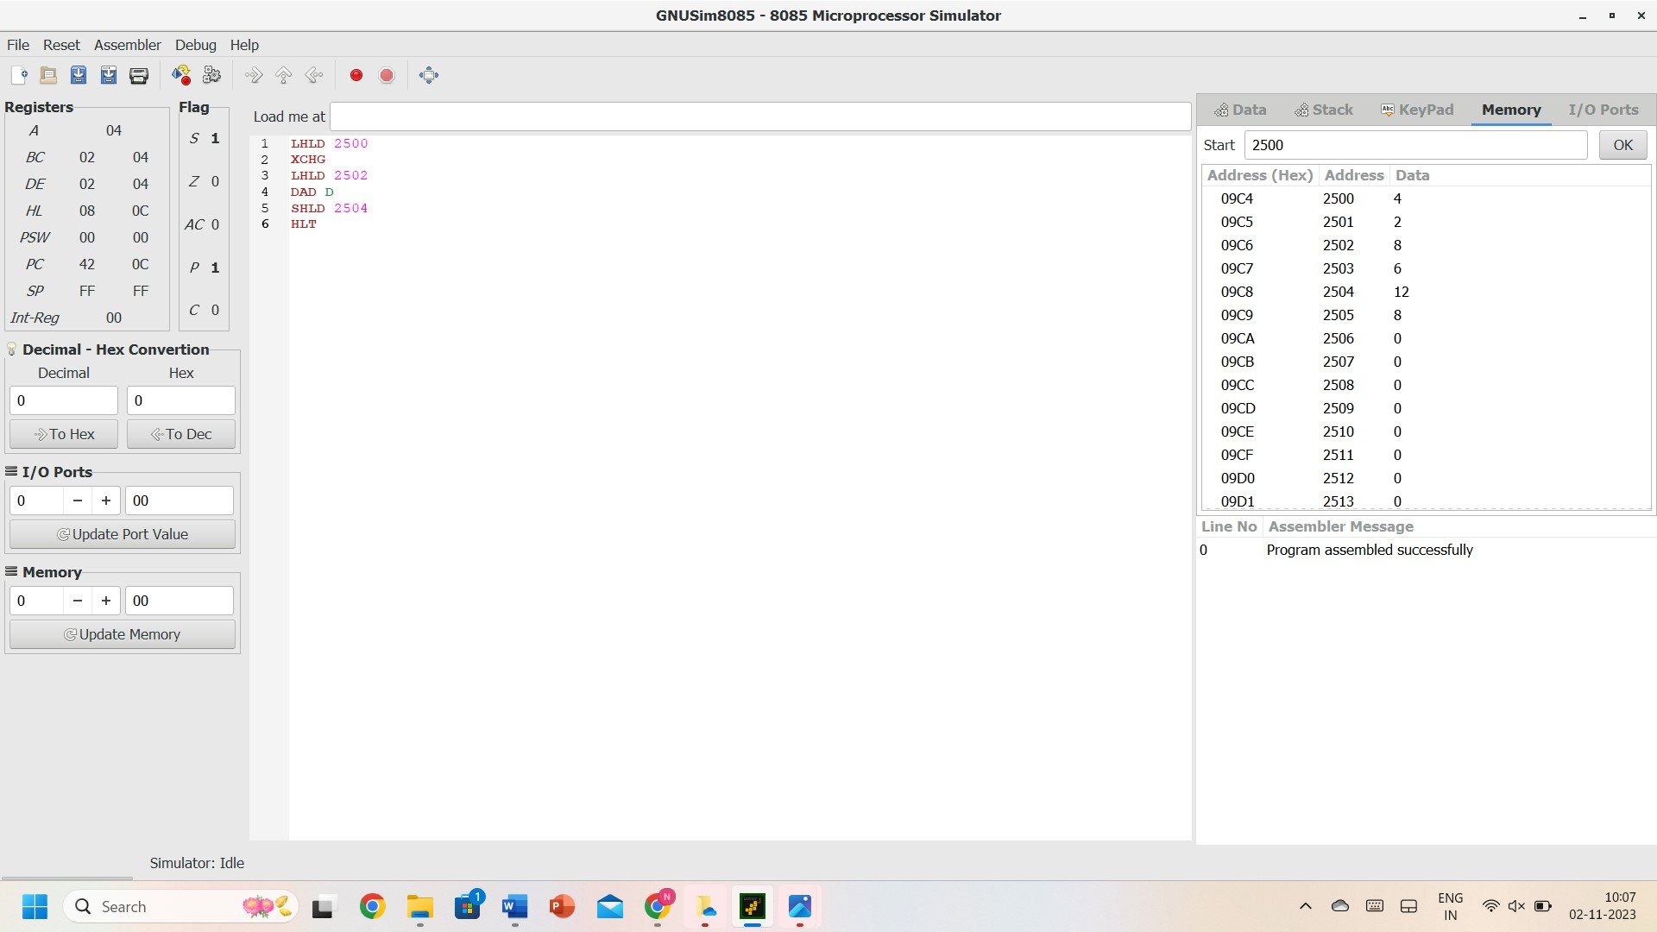

**RESULT:** Thus, the program was executed successfully using 8085 processor simulators.